**DAILY ONLINE ACTIVITIES SUMMARY**

|  |  |  |  |  |  |  |  |  |
| --- | --- | --- | --- | --- | --- | --- | --- | --- |
| **Date:** | 17-06-2020 | | | | | **Name:** | D Richard Franklin | |
| **Sem & Sec** | Fourth sem section A | | | | | **USN:** | 4AL18CS020 | |
| **Online Test Summary** | | | | | | | | |
| **Subject** | | N/A | | | | | | |
| **Max. Marks** | | - | | **Score** | | | - | |
| **Certification Course Summary** | | | | | | | | |
| **Course** | 1. **Mastering big data analytics** | | | | | | | |
| **Certificate Provider** | | | greatlearning | | **Duration** | | | 3 hr |
| **Coding Challenges** | | | | | | | | |
| **Problem Statement:**  1: program to print numbers from 1 to n where none of the numbers contain 3 as its digit. | | | | | | | | |
| **Status:** completed | | | | | | | | |
| **Uploaded the report in Github** | | | | | yes | | | |
| **If yes Repository name** | | | | | <https://github.com/alvas-education-foundation/Richard_Franklin> | | | |
| **Uploaded the report in slack** | | | | | yes | | | |

**Online Test Details: N/A**

**Online Course Details:**

1. Name of course: **Mastering big data analytics**

Certificate provider: greatlearning

The total course was about how we can get thorough with big data analysis and to master the art. Today I went through the section of the course which was about Apache kafka. Here I learnt how this streaming platform is useful for big data analysis. The components, partitions and all other information regarding this platform was told here.

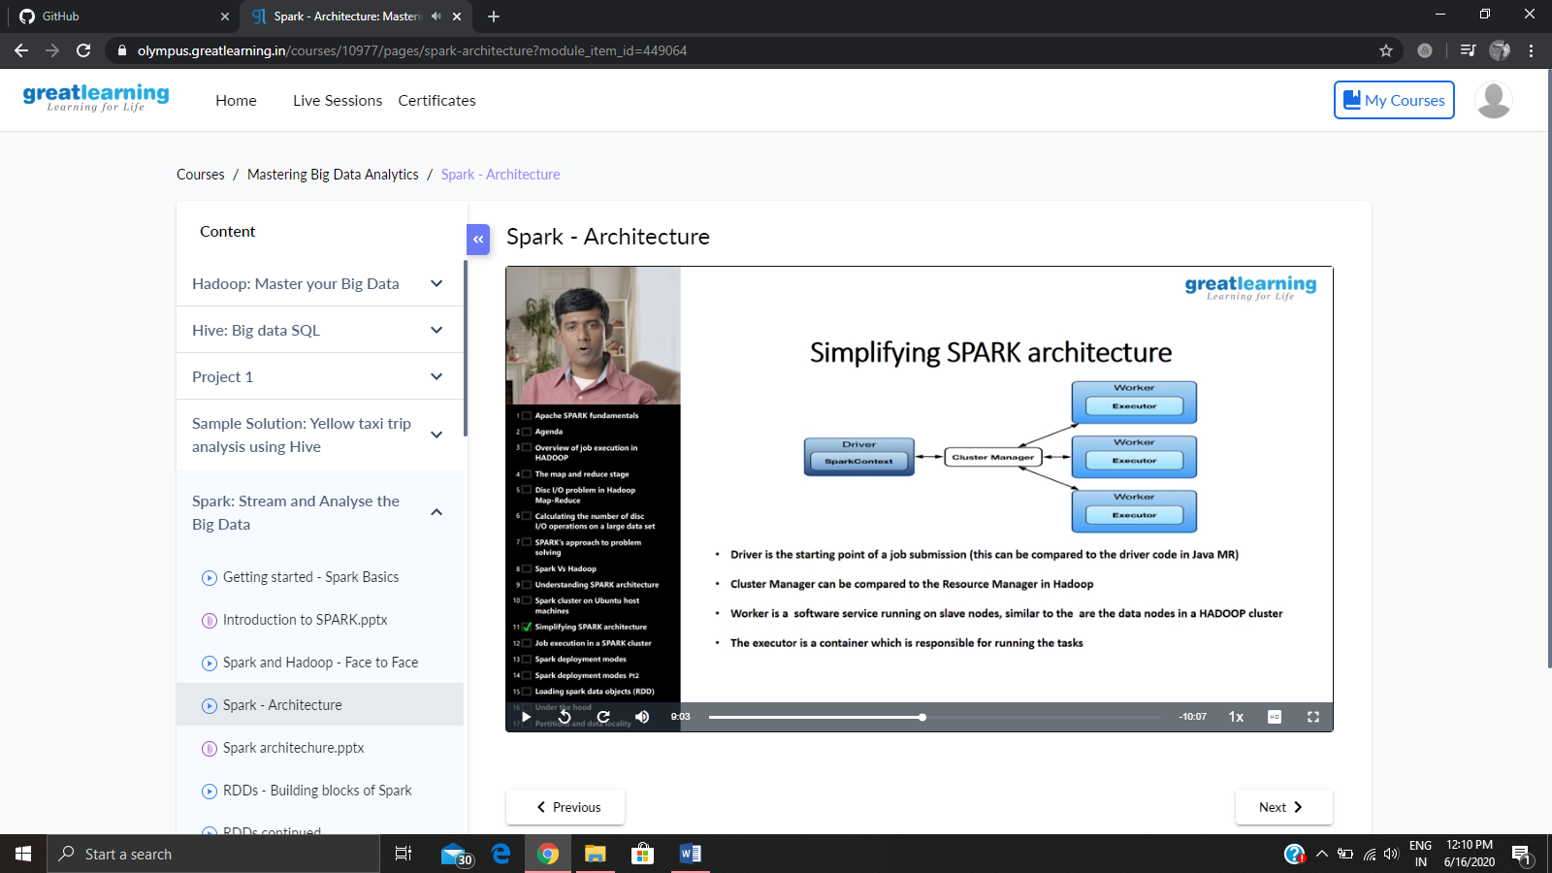

**Online coding:**

Problem 1: (using C language) program to print numbers from 1 to n where none of the numbers contain 3 as its digit.

